Agentic AI-Based Intelligent Travel Planning System
Software Requirement Specification

Final-Year Project (BTech Information Technology)
Academic Prototype

Document Issue Status
Document ID: ATP/SRS |  | Document Issue Number: 1  Document Revision Number: 0
Prepared by | Ashfaque C , Muhammad Fawas K  Abel Mathew , Afrah Shad EK | Prepared Date:
Reviewed by |  | Reviewed Date:
Approved by |  | Approved Date:
Distribution list
Document Amendment Record
Sl. No. | Issue No | Revision No | Date | Pages Corrected | Remarks
1 | 1 | 0 |  | All | Initial issue

Contents
1 Introduction 5
1.1 Purpose 5
1.2 Scope 5
1.3 Product / System Overview 5
1.4 User Characteristics 6
1.5 Definitions, Acronyms & Abbreviations 6
1.6 Constraints 7
1.7 Assumptions and Dependencies 7
1.8 References 7
2 Functional Requirements 8
2.2 Use Cases 10
3 Non-Functional Requirements 12
3.1 Performance Requirements 12
3.2 Security Requirements 12
3.3 Software System Attributes 12
4 External Interface Requirements 14
4.1 User Interfaces 14
4.2 Hardware Interfaces 14
4.3 Software Interfaces 14
4.4 Communication Interfaces 14
5 Acceptance Criteria 15
6 Appendices 15
6.1 User Need Document 15
6.2 Requirement Traceability Matrix 15
6.3 Product Backlog 16
6.4 Future Enhancements 16

1 Introduction

1.1 Purpose
This Software Requirement Specification (SRS) defines the functional and non-functional requirements of the Agentic AI-Based Intelligent Travel Planning System. It describes what the system must do so that designers can design it and testers can test it.
Intended audience: the project team (developers and testers), the project guide and review panel, and students or researchers who want to study the system as an example of agentic AI and multi-agent coordination.

1.2 Scope
The software product is called the Agentic AI-Based Intelligent Travel Planning System. It is a web application that turns a natural-language travel request into a personalized, budget-aware, day-wise itinerary. A coordinated planning process integrates transportation, accommodation, geospatial, weather and safety information.
The system will:
- Accept a travel request (origin, destination, duration, travelers, budget, preferences, interests).
- Suggest transport, accommodation, attractions and restaurants, and estimate routes, distances and costs.
- Check weather and nearby essential services (hospitals, pharmacies, police stations).
- Check the plan against budget, duration and preferences.
- Show the day-wise itinerary, estimated budget and an interactive map.
The system will not:
- Book tickets or hotels, or process payments.
- Guarantee exact fares, availability or real-time safety alerts. All costs and recommendations are estimates unless a verified source supplies current data.
Benefit and goal: reduce the manual effort of searching many separate platforms, using a modular, low-cost, open-source approach. The prototype uses open-source tools and public services where possible. This matches the project summary.

1.3 Product / System Overview
The system has a React frontend, a FastAPI backend, a LangGraph-based multi-agent layer (Supervisor plus four specialized components) powered by a local LLM through Ollama, and a PostgreSQL/PostGIS database. The planning components obtain information from tools and data sources such as OpenStreetMap services, OSRM, Open-Meteo, transit feeds and a curated accommodation dataset.
Workflow: the user submits a request, the system interprets it, divides the planning work into relevant tasks, obtains required information, validates the collected information and budget, and produces the itinerary, map and budget summary.
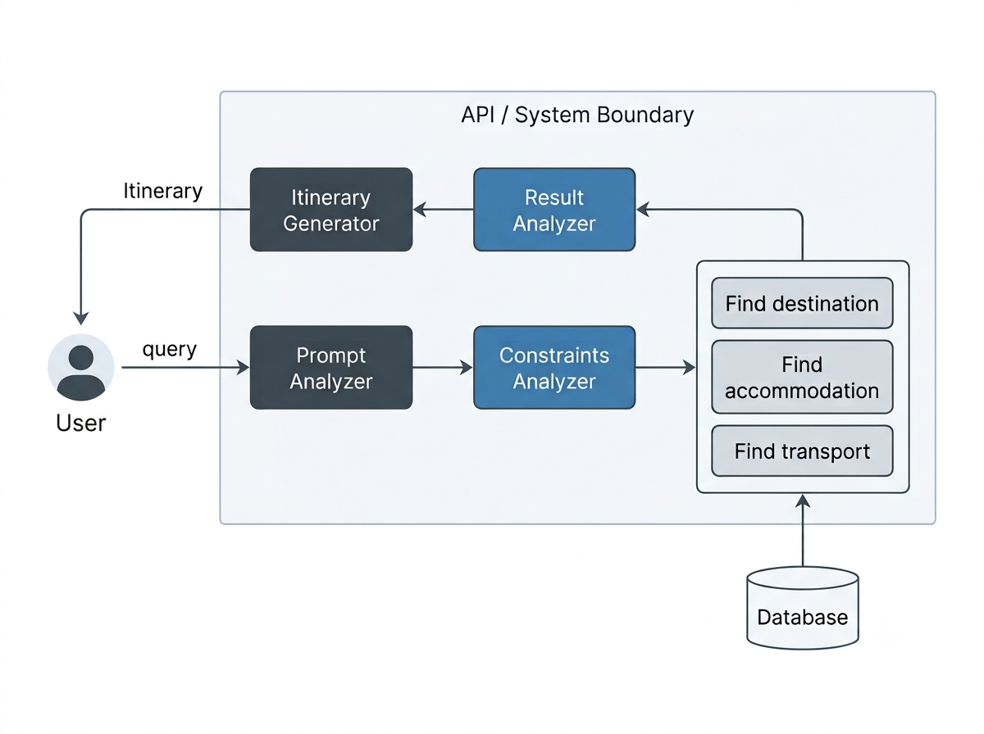
Figure 1: System block diagram

1.4 User Characteristics
User | Characteristics and effect on requirements
Traveler | Basic computer and internet knowledge. Does not know about AI, LLMs, APIs or databases. So the interface must be simple and accept plain-language requests (NFR-16, NFR-17).
Student / Researcher | Technical background. Uses the system to study agentic AI, multi-agent systems and geospatial planning. Needs clear separation of agents and tools (NFR-23, NFR-24).
Administrator | Technical user who maintains configuration, datasets and accommodation records.

1.5 Definitions, Acronyms & Abbreviations
Term | Meaning
Agent | A task-oriented software component that does one specific job
Agentic AI | AI that can plan, reason, use tools, coordinate actions and adapt to change
LLM | Large Language Model
LangGraph | Framework used to orchestrate the agent workflow and shared state
Ollama | Tool for running an open-source LLM locally
API | Application Programming Interface
POI | Point of Interest (attraction, restaurant, hospital, etc.)
OSM | OpenStreetMap
OSRM | Open Source Routing Machine (road routes and distances)
OTP | OpenTripPlanner (multimodal routing)
GTFS | General Transit Feed Specification (public transit data)
PostGIS | Geographic extension for PostgreSQL
SRS / UI / UX | Software Requirement Specification / User Interface / User Experience

1.6 Constraints
- Data and regulatory: recommendation quality depends on external data. Public APIs (Nominatim, Overpass, OSRM, Open-Meteo) have rate limits and usage policies that must be respected.
- Data coverage: public transport data (GTFS) may not exist for every location. Real-time hotel availability needs commercial or partner APIs, so the prototype uses a curated accommodation dataset.
- Hardware: a local LLM through Ollama needs enough RAM/GPU; model size and speed limit response time and quality.
- Language and tools: Python backend (FastAPI, LangGraph) and React frontend; PostgreSQL with PostGIS for data.
- Reliability: LLM output may contain errors and must not be treated as the authority for prices, schedules, ratings or safety.
- Security: API credentials must stay on the backend and user data must be protected.
- Criticality: the system is an academic prototype, not a commercial booking platform. Safety information is advisory only.

1.7 Assumptions and Dependencies
- Users give reasonably valid travel requirements.
- External services (Nominatim, Overpass, OSRM, Open-Meteo) are reachable during planning.
- Map data exists for the selected destination.
- Transit feeds are available wherever transit recommendations are needed.
- Accommodation data is available from the local dataset or an approved provider.
- The chosen local LLM is capable enough for requirement extraction and itinerary text.
- Windows or Linux with Python, Node.js, Docker (where needed), PostgreSQL with PostGIS and Ollama installed.

1.8 References
No. | Document | Source
1 | Agentic AI-Based Intelligent Travel Planning System: Professional Project Summary | Project team
2 | Software Requirement Specification Template | Institution / course
3 | Documentation of LangGraph, FastAPI, Ollama, PostgreSQL/PostGIS, MapLibre GL JS | Official project websites
4 | Documentation of Nominatim, Overpass API, OSRM, Open-Meteo, GTFS, OpenTripPlanner | Official project websites

2 Functional Requirements
Each requirement has a unique ID. Requirements are written so that users or external systems can observe them. Input, output and processing are listed per module.

2.1 Travel Request Module
Input: origin, destination, duration, travelers, budget, preferences, interests, or a free-text request. Output: a validated travel request ready for travel planning.
ID | Requirement
FR-01 | The system shall let the user enter the starting location.
FR-02 | The system shall let the user enter the destination.
FR-03 | The system shall let the user specify travel duration.
FR-04 | The system shall let the user specify the number of travelers.
FR-05 | The system shall let the user specify the total budget.
FR-06 | The system shall let the user specify transport preferences.
FR-07 | The system shall let the user specify accommodation preferences.
FR-08 | The system shall let the user specify interests (historical places, nature, shopping, food, entertainment).
FR-09 | The system shall accept natural-language travel requests.
FR-10 | The system shall validate mandatory information before planning starts.
FR-11 | The system shall interpret the travel request and extract relevant planning parameters from natural-language input.
FR-12 | Extract origin, destination, duration, travelers, budget, interests and preferences.
FR-13 | The system shall decompose the travel request into relevant planning subtasks.
FR-14 | The system shall process transport-related requirements and identify suitable transportation options.
FR-15 | The system shall process accommodation requirements and identify suitable accommodation options.
FR-16 | The system shall process location-related information and determine suitable routes and distances.
FR-17 | The system shall assess weather and safety-related information that may affect the travel plan.
FR-18 | The system shall collect and validate information obtained from the relevant planning processes before generating the travel plan.
FR-19 | The system shall evaluate the travel plan against the user's budget, duration, route practicality and preferences.
FR-20 | The system shall calculate the total estimated expenditure for the proposed travel plan.
FR-21 | The system shall generate a day-wise itinerary based on the user's travel requirements, preferences and available information.
FR-23 | The system shall identify suitable transportation options using available transportation data.
FR-24 | Consider the user's transport preferences.
FR-25 | Obtain route information, estimated distance and estimated travel time.
FR-26 | Estimate transport cost when suitable data is available.
FR-27 | The system shall compare available transportation alternatives and identify suitable options based on the user's requirements.
FR-28 | The system shall identify accommodation options from the available accommodation dataset.
FR-29 | Filter options by the user's budget, location, rating (where available) and preferences.
FR-30 | The system shall estimate accommodation expenses and identify suitable options based on the user's requirements.
FR-31 | The system shall convert place names into geographic coordinates.
FR-32 | The system shall identify tourist attractions, restaurants and cafés near selected locations.
FR-33 | The system shall identify nearby points of interest and support distance-based filtering.
FR-34 | The system shall calculate distances and provide suitable road routes between selected locations.
FR-35 | The system shall provide location and route information for use in generating the travel plan.
FR-36 | The system shall obtain weather information for the planned destinations.
FR-37 | The system shall identify unfavorable weather conditions and provide appropriate warnings when they may affect the travel plan.
FR-38 | Identify mapped hospitals, police stations and pharmacies near the destination where data exists.
FR-39 | The system shall identify safety conditions that may affect the travel plan and provide appropriate notifications.
FR-40 | Calculate estimated trip expenses per category.
FR-41 | Compare the estimate against the user's budget and identify violations.
FR-42 | The system shall identify lower-cost alternatives when the estimated expenses exceed the user's budget.
FR-43 | Display the estimated total cost and remaining budget.
FR-44 | Generate a day-wise itinerary with planned activities, transport information and estimated costs.
FR-45 | Consider geographic proximity between activities, available time and user preferences.
FR-46 | The system shall present the generated travel information as an interactive map and budget summary.
FR-51 | The system shall display the destination, attractions, accommodation, restaurants and other points of interest on an interactive map.
FR-52 | Display routes where route data is available and show the relationship between planned locations.
FR-53 | The system shall store travel requests, accommodation data, geographic data and generated itineraries for future retrieval.
FR-54 | Retrieve stored information during planning.
FR-55 | The system shall support geographic coordinates and distance-based spatial queries, such as identifying restaurants within a specified distance of a selected hotel.

2.2 Use Cases
Figure 2 shows the actors and use cases of the system. The Traveler creates and views travel plans. The Administrator maintains the hotel data and system settings. External services supply transit, map and weather data.
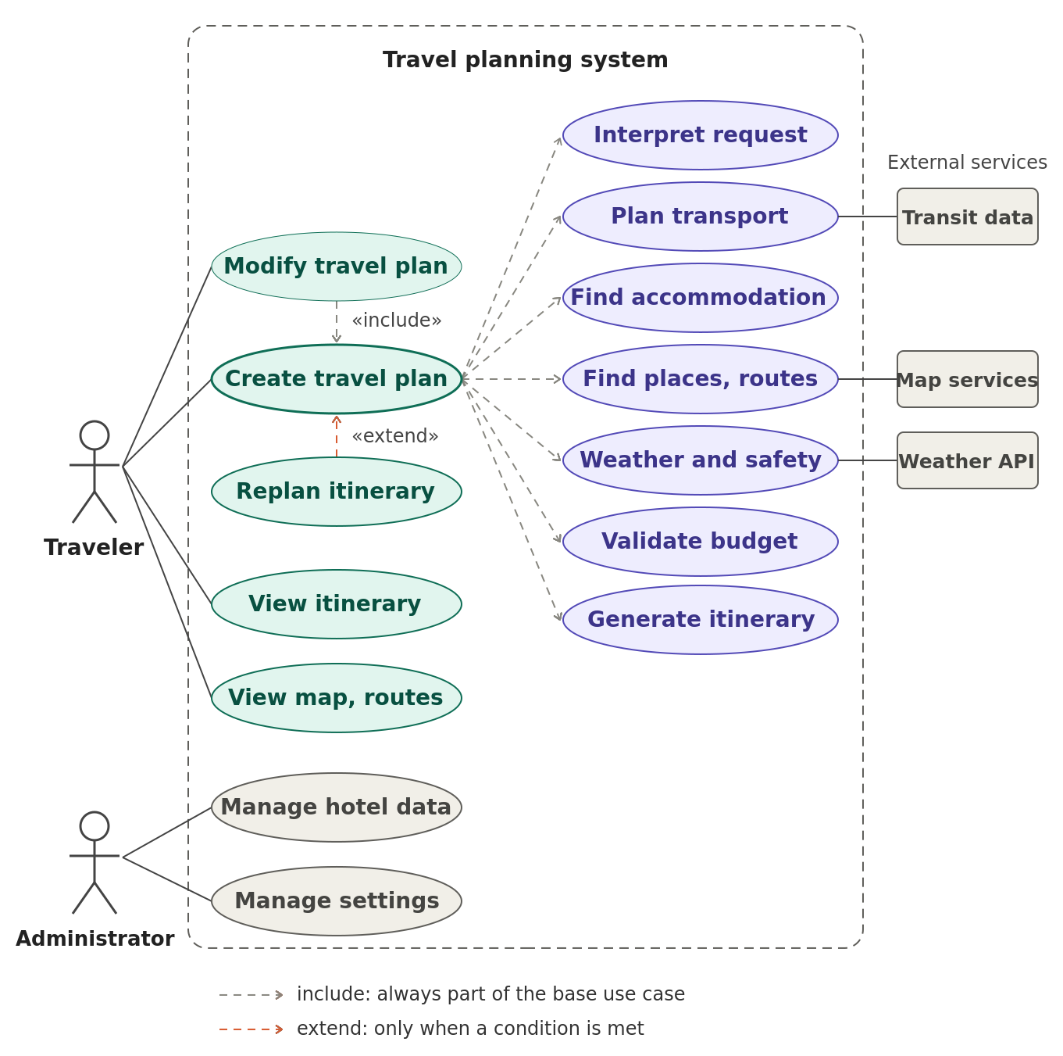
Figure 2: Use case diagram
UC-01: Create Travel Plan (Actor: Traveler)
- Precondition: user can open the web application.
- Flow: user enters origin, destination, duration, travelers, budget and preferences, then submits. The backend validates the request, processes the required planning information, checks the budget, and displays the itinerary, map and budget summary.
- Alternate flow: if required information is missing or an external service does not provide data, the system displays the available information and marks missing or estimated data appropriately.
UC-02: View Travel Plan (Actor: Traveler)
- Flow: user selects an existing plan and views its details, including the itinerary, map, budget and available travel information.

Example scenario
Input: "Plan a 5-day trip from Kochi to Hyderabad for 2 people with a budget of ₹6000. Prefer budget transportation and accommodation. I am interested in historical places and local food." Expected output: transport options, stays, attractions, local food places, routes, weather and safety information, daily and total estimated cost, remaining budget, day-wise itinerary and map. The ₹6000 is a user-defined constraint, not a guarantee that the trip is feasible at that price.

3 Non-Functional Requirements

3.1 Performance Requirements
The targets below are prototype goals on a typical development laptop running a local LLM, and will be confirmed during testing.
ID | Requirement
NFR-01 | The system shall process travel planning requests within a reasonable response time and provide the generated travel plan without unnecessary delay, depending on the complexity of the request and availability of external data sources.
NFR-02 | The system shall support at least 5 simultaneous users in the prototype.
NFR-03 | Frequently used geographic results (geocoding, routes, POIs) shall be cached to avoid repeated external requests.
NFR-04 | External API calls shall be minimized and shall respect each provider's rate limits.

3.2 Security Requirements
ID | Requirement
NFR-05 | User data stored in the database shall be protected from unauthorized access.
NFR-06 | API credentials shall be kept on the backend and never exposed in the frontend.
NFR-07 | The backend shall validate all incoming user data.
NFR-08 | Secure communication (HTTPS) shall be used in deployment.
NFR-09 | The system shall keep logs of agent runs and external-service errors.

3.3 Software System Attributes
Reliability and accuracy
ID | Requirement
NFR-10 | The system shall handle external API failures gracefully, and one failing service shall not stop the whole planning process.
NFR-11 | The system shall clearly mark unavailable or incomplete information and shall not present unavailable data as verified.
NFR-12 | Factual data (prices, schedules, ratings, safety) shall come from databases or external sources, not only from LLM text.
NFR-13 | The system shall distinguish verified information from estimated information.

Usability
ID | Requirement
NFR-14 | The interface shall be simple, and results shall be shown in a structured, readable format.
NFR-15 | The itinerary shall be readable on desktop and mobile-sized screens.

Scalability, portability and maintainability
ID | Requirement
NFR-16 | New agents, data providers and destinations shall be addable without redesigning the system.
NFR-17 | The system shall run on Windows and Linux, and in modern web browsers.
NFR-18 | Agents shall be separate logical components, with tools kept separate from agent logic and database code separate from presentation logic.
NFR-19 | The source code shall be managed with Git/GitHub.

Availability
Not Applicable. The prototype is not intended for continuous production service.

4 External Interface Requirements

4.1 User Interfaces
- Travel request page: a form for origin, destination, duration, travelers, budget, preferences and interests, plus a free-text box for natural-language requests.
- Result page: day-wise itinerary, cost breakdown with total and remaining budget, weather and safety notes, and an interactive map with markers and routes.
- Plan page: option to view an existing travel plan and its details.
- Responsive layout with Tailwind CSS; messages show when data is missing or estimated. Wireframes will be added during design.

4.2 Hardware Interfaces
No special hardware interfaces. The backend host needs enough RAM (and preferably a GPU) to run the local LLM through Ollama. Users need a device with a modern web browser.

4.3 Software Interfaces
Software | Version | Source | Purpose
React.js, Tailwind CSS, MapLibre GL JS | Latest stable | Official sites / npm | Frontend, styling, maps
Python, FastAPI | Latest stable | python.org / PyPI | Backend API and logic
LangGraph | Latest stable | PyPI | Agent workflow and state
Ollama + open-source LLM | Latest stable | ollama.com | Local language model
PostgreSQL + PostGIS | Latest stable | postgresql.org / postgis.net | Application and spatial data
Nominatim, Overpass API | Public service | OpenStreetMap | Geocoding and POI discovery
OSRM | Public service | project-osrm.org | Road routes, distance and time
Open-Meteo | Public API | open-meteo.com | Weather data
GTFS / OpenTripPlanner | Where available | Transit agencies | Public transit data

The backend calls these services over REST/JSON. Message formats are defined in each provider's documentation, so only references are given here.

4.4 Communication Interfaces
- Frontend to backend: HTTPS with REST APIs and JSON.
- Backend to external services: HTTPS REST APIs.
- Backend to Ollama and PostgreSQL: local network connections on the host or Docker network.

5 Acceptance Criteria
The software is accepted when the following checks pass:
No. | Check | Method
AC-01 | A natural-language request is converted into correct parameters (origin, destination, duration, travelers, budget). | Test with sample requests
AC-02 | The planning process produces structured transport, accommodation, location, weather and safety information for the travel request. | Integration test
AC-03 | The itinerary is day-wise, includes costs, and the total is compared with the budget. | Scenario test (Kochi to Hyderabad)
AC-04 | When the budget is exceeded, the system identifies lower-cost alternatives or clearly indicates the budget violation. | Budget-violation test
AC-05 | Map shows locations and routes consistent with the itinerary. | UI test
AC-06 | When an external service is down, the system still returns a plan and marks missing data. | Failure test
AC-07 | Estimated values are labeled as estimates, and no feature claims live booking or verified fares. | Review
AC-08 | Each feature is classified as implemented, partially implemented or planned in the demonstration. | Review

6 Appendices

6.1 User Need Document
Agentic AI-Based Intelligent Travel Planning System: Professional Project Summary (Reference 1).

6.2 Requirement Traceability Matrix
Need (Project Summary) | Requirements | Acceptance
Natural-language requirement analysis | FR-01 to FR-12 | AC-01
Planning task coordination | FR-13 to FR-21 | AC-02
Budget estimation and validation | FR-40 to FR-43 | AC-03, AC-04
Transportation and route planning | FR-23 to FR-27 | AC-02
Accommodation recommendations | FR-28 to FR-30 | AC-02
Geospatial discovery and maps | FR-31 to FR-35, FR-51, FR-52 | AC-05
Weather and essential-service awareness | FR-36 to FR-39 | AC-02
Day-wise itinerary generation | FR-44 to FR-46 | AC-03, AC-05

6.3 Product Backlog
Not Applicable.

6.4 Future Enhancements
Real-time transport information, commercial hotel providers and live availability, flight-price integration, saved trips and user accounts, voice and multilingual requests, mobile app, advanced route optimization, real-time alerts, itinerary regeneration and human approval before major itinerary changes.

